

NEWS

Last updated at 1:46 PM on 17/01/08

Horses benefitting from ancient form of healing
Reiki therapy not only curing physical ailments, but mental ones too
LOWER SACKVILLE
BOBBIE-LYNN HALL
The Bedford Sackville Weekly News

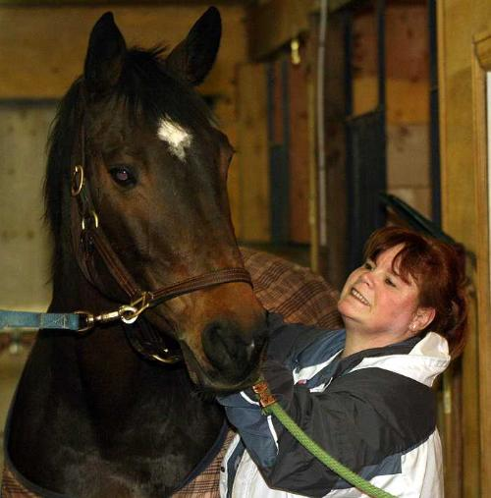
Sarah Findley uses reiki on Zophia at the Restless Pines Farm in Hammonds Plains to treat a number of ailments in the seven-year-old horse. (Darrell Oake photo)

An ancient form of healing is being used to help ease the pain and anxiety of man and beast.
Reiki is believed to have spread through Tibet, China and India more than 100 years ago. In recent years, the energy-based form of healing has become more and more recognized in the mainstream treatment of ailments ranging from stress headaches to arthritic pain. People around the world are now benefiting from the gentle, non-invasive treatments, and as it turns out, so are our four-legged friends.
"I am certified to work on animals," said Sarah Findley, a reiki healer from Lower Sackville. "I have dogs coming in and out of my shop all the time."
Zophia, a seven-year-old Oldenburg horse, can't just walk through the door, so Findley goes to her.
Zophia receives reiki treatments on a regular basis and her owner, Heidi MacInnis of Restless Pines Farm in Hammonds Plains, said the results are undeniable.
Pulled a ligament
"Just recently Zophia pulled a ligament, and I called Sarah," she said. "After the treatment her leg was better. We use the reiki as part of routine maintenance of our animals, and when they are injured we call the vet and then we call Sarah. Sometimes we just call Sarah."
MacInnis owns 25 of her own jumping horses and boards an additional 15. She has a riding school and shows horses on a regular basis. Besides the typical strains on leg muscles expected from jumping horses, there is often anxiety and a little stress for the horses before and after a show. According to Findley and MacInnis, equine reiki helps the horses relax.
A typical treatment has Findley walking around the horse gently touching the animal in specific points of energy, and in the case of an injury, she works in that specific area.
"It works the same as it does with people," said Findley. "It relaxes all over, and just makes them feel better."
Many people out there may believe an equine-reiki treatment may help a horse relax, but there are certainly many more who would question the validity of the healing aspect of the practice. For those non-believers, MacInnis has a pretty amazing story.
"We had a horse that was very sick," she said. "The vet said it was a surgical case and his owners decided not to have it done. He was set to be euthanized and we decided to try and bring him back ourselves. We called on Sarah as a part of our treatment and he made it; he's in the riding school right now."
The only difference between reiki on horses and reiki on people is the size of the recipient. You also have to be comfortable around horses because they may not always be in the mood for a treatment. Finally, it's interesting to know, Findley said, that animals don't have a belief system, so they are more open to accept the treatment without any doubts as to its effectiveness. Therefore, they may benefit that much more.
Findley doesn't always wait for a call. Sometimes she just drops in to hang with her "friends.'
"The farm is very grounding to me, so it's kind of a two-way deal," she said. "I make them feel better and they do the same for me."

COLUMNS
Post a comment |

Last updated at 1:46 PM on 17/01/08
Reiki therapy 'feels great'

BOBBI-LYNN HALL
The Bedford Sackville Weekly News
I went to Sarah's Spiritual Treasures last year to buy some healing stones for my mom. I was pretty sure they wouldn't heal her, but I figured just holding them might make her feel a little better. And they did.
While at Sarah Findley's store I looked around and was intrigued by the crystals and angels and candles, so I made a mental note to return.
As with most of my mental notes, this one went in one side and out the other. And then, just a couple of weeks ago, I heard about re-connective healing and thought it would be a fun thing to do for the column.
Reconnective healing
When I found out Findley did it, the little note came back. I asked her about reconnective healing and she agreed to give me a treatment.
Sarah practices her relaxation, reiki, reconnective and other healing treatments in a cosy room in the back of her store.
The room is filled with pendulums, angels and stones and smells amazing. You can't help but relax as soon as you walk in.
Findley is an internationally registered healer with many certificates hanging on her walls. She calls what she does "energy work" and says holistic healing is finally making its way into the main stream.
"It's not the big voodoo it used to be," she said.
My reconnective treatment began with Findley placing her hands at the back of my neck until I was completely relaxed.
Fell asleep
My eyes were closed, but I could hear her walking around me, and I could feel myself relaxing more and more. I think I fell asleep, but I guess that's OK; it just made the time go by way too quickly.
According to Findley, reconnective healing is a hands-off healing modality that utilizes new frequencies for the healing of mind, body and spirit.
These frequencies reduce stress and introduce profound relaxation. It is considered to be able to reconnect us to our very essence, not just through a new set of healing frequencies, but through possibly an entirely new bandwidth.
According to me it just feels great.
For more information on holistic healing visit www.sarahsspiritual treasures.com
blhall@eastlink.ca
18/01/08

